How to Create a Public S3 Bucket and Upload an Object

Objectives
- Create a bucket in Amazon S3
- Add an object to a bucket
- Manage access permissions on an object and a bucket
- Create a bucket policy
- Use bucket versioning

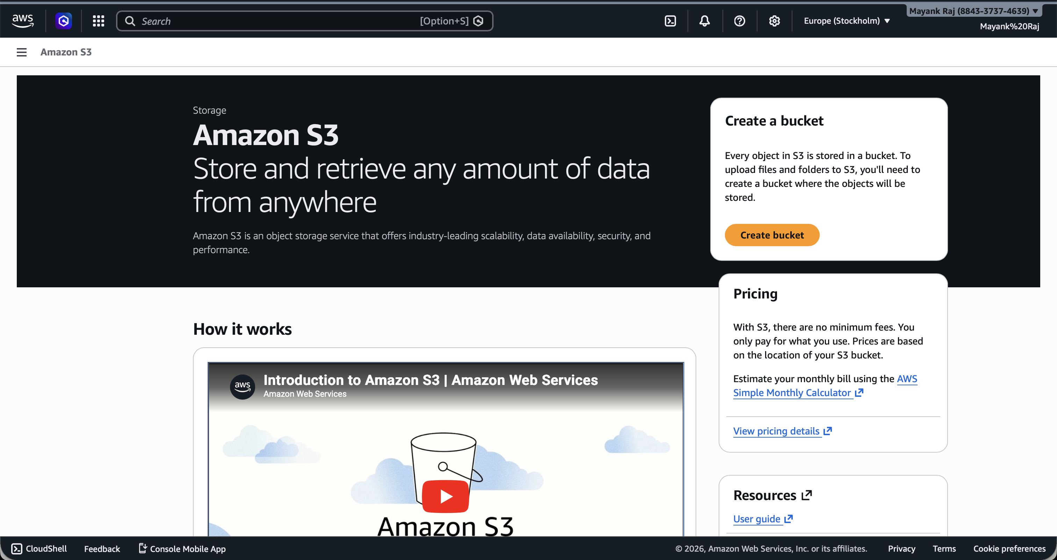
- Go to S3 in the AWS Console — Navigate to the S3 service from the AWS Management Console.

- Create a new bucket — Click "Create bucket", enter a unique bucket name, and select your preferred AWS region and under object ownership enable ACLs and object writer.

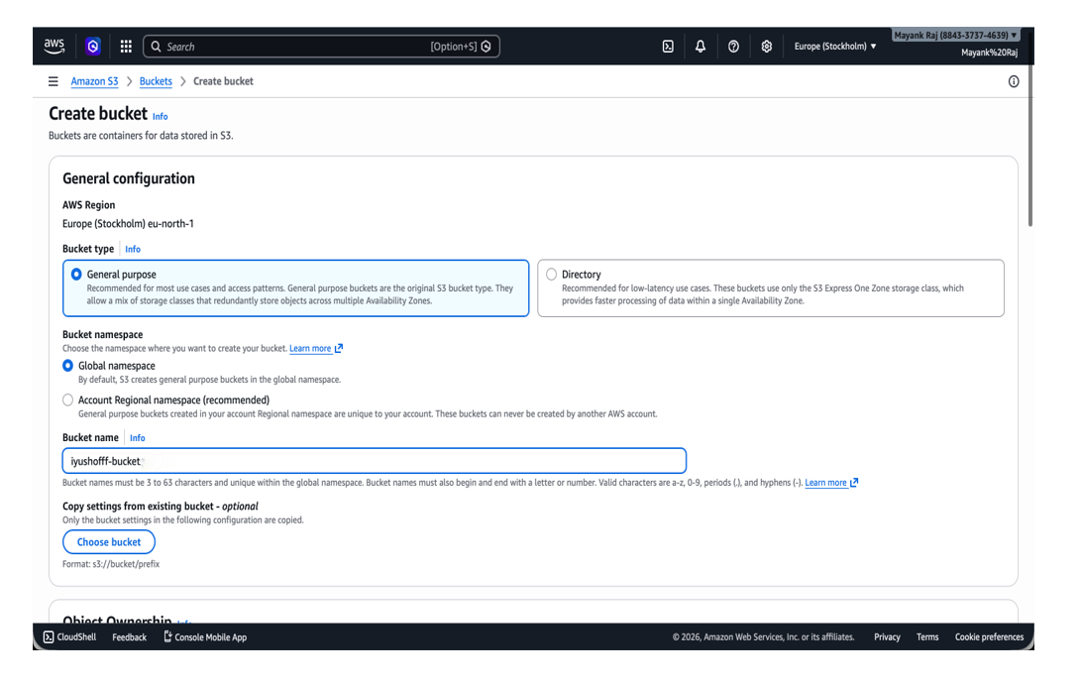
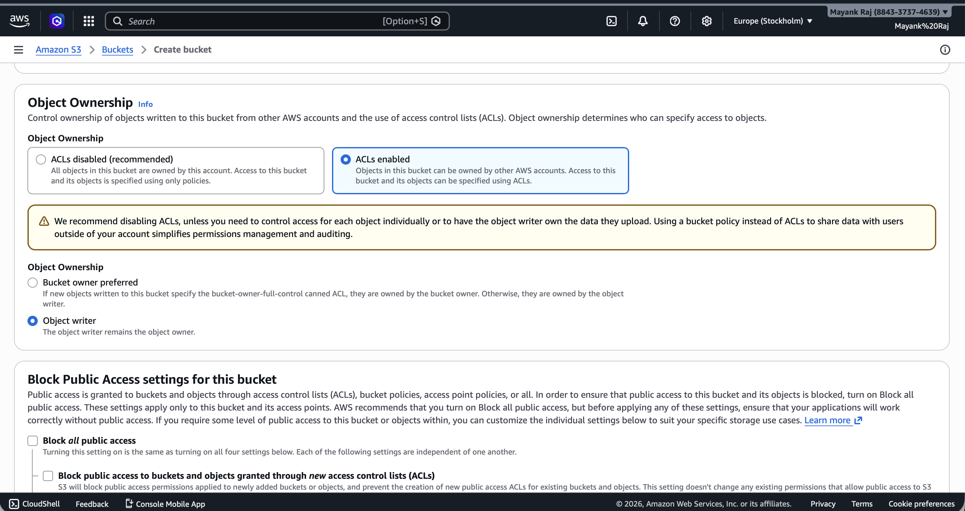
- Disable "Block Public Access" settings — Uncheck the "Block all public access" option and acknowledge the warning to allow public access to the bucket.

- Finish creating the bucket — Review the settings and click "Create bucket" to finalize.

- Upload an object — Open the newly created bucket, click "Upload", and add your file(s).

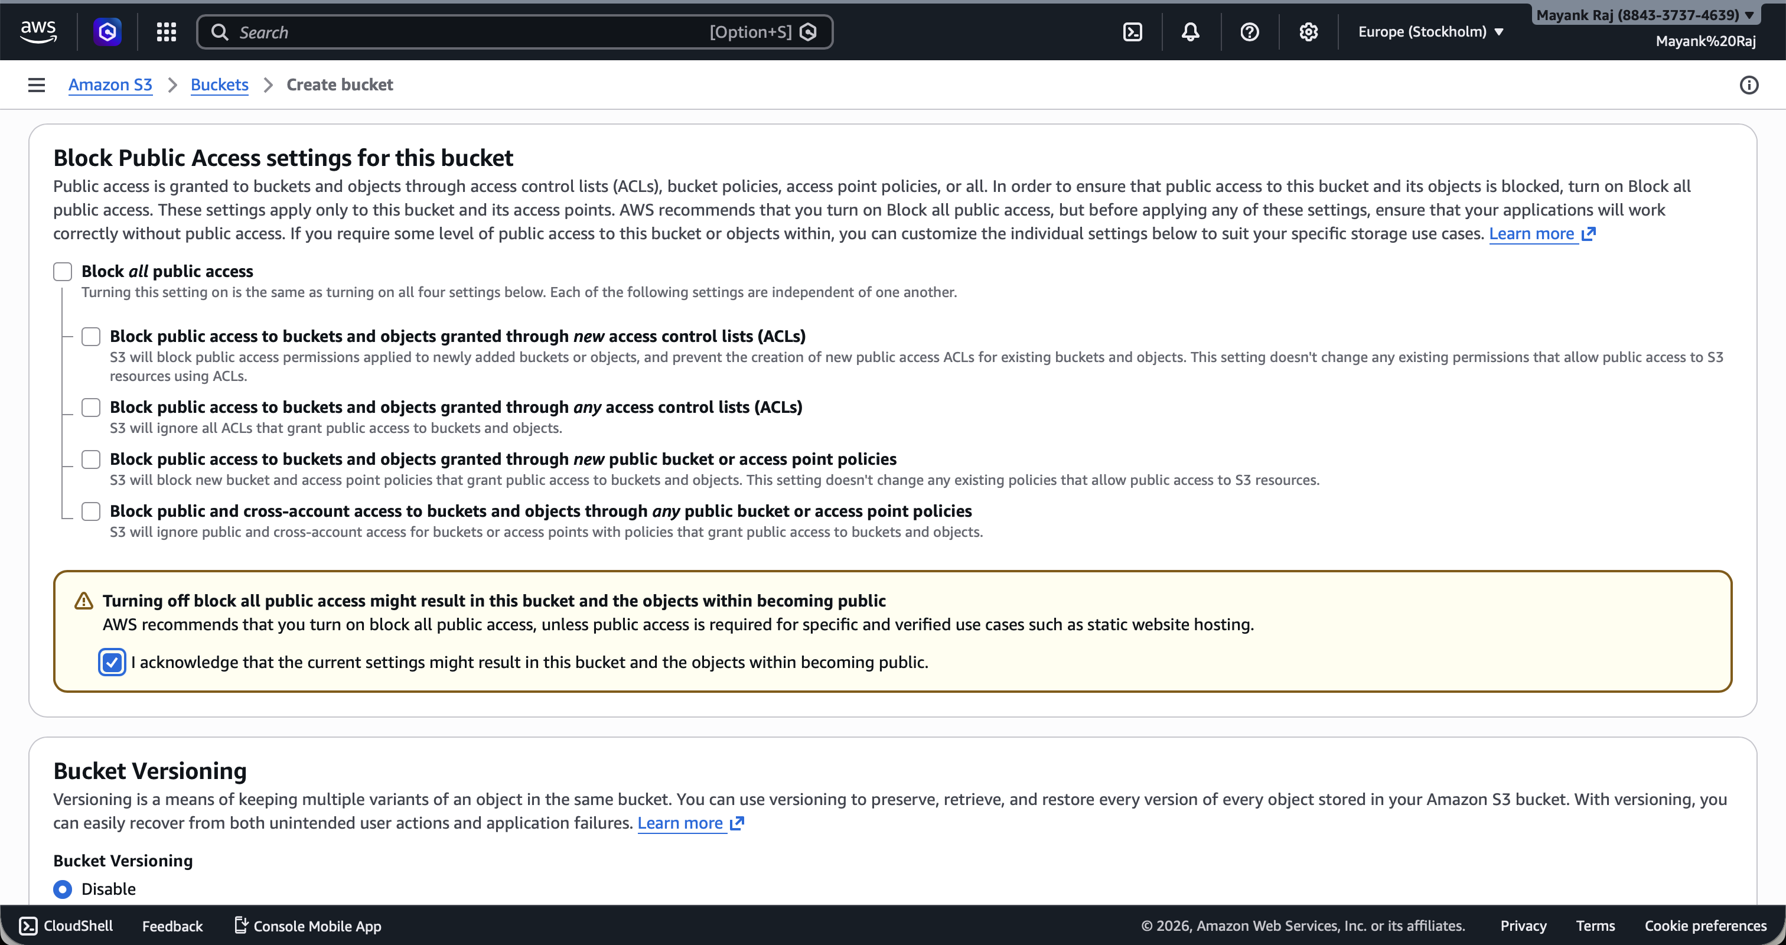
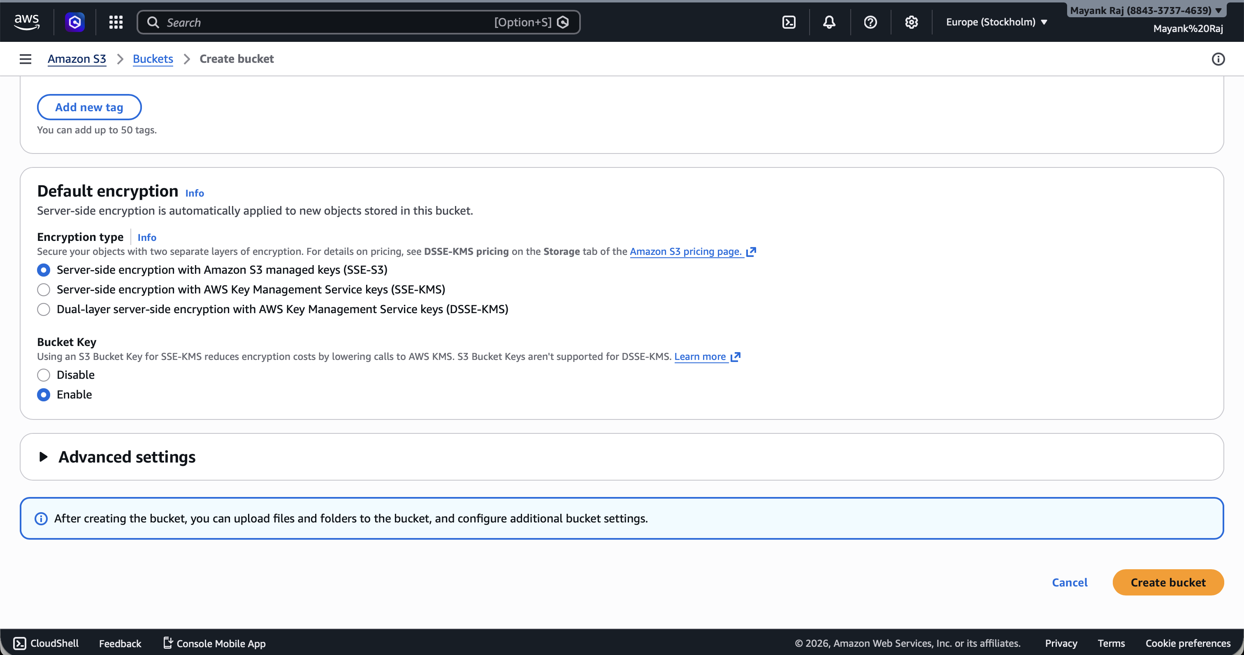
- Make the object public — After uploading, set the object's permissions by using make public using ACL.
